37: . John Smith is a new car salesperson. Write the algorithm to calculate the total cost of a car given the following. In Addition, write the pseudocode and draw the flowchart: initial price of the car 0 to 10 accessories (the computer would select the price according to the accessory) sales tax

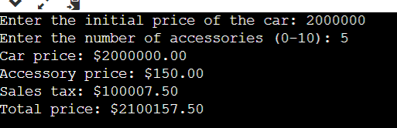

38: The Last Stop Boutique is having a five-day sale. Each day, starting on Monday, the price will drop 10% of the previous day’s price. For example, if the original price of a product is $20.00, the sale price on Monday would be $18.00 (10% less than the original price). On Tuesday the sale price would be $16.20 (10% less than Monday). On Wednesday the sale price would be $14.58; on Thursday the sale price would be $13.12; and on Friday the sale price would be $11.81. Develop a solution that will calculate the price of an item for each of the five days, given the original price. Write the algorithm, flowchart and pseudocode to test the solution. 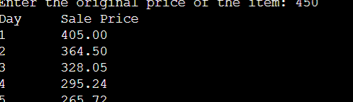

39: Mary Smith, a student, has borrowed $3,000 to help pay her college expenses. After setting up a budget, $85 was the maximum monthly payment she could afford to make on the loan. Develop a solution to calculate and print the interest, the principal, and the balance on the loan per month. Other information she would like to know is the number of years and months it will take to pay the loan back and the total interest she will pay during that period. The interest rate is 1% per month on the unpaid balance. Write the algorithm, flowchart and pseudocode to test the solution.

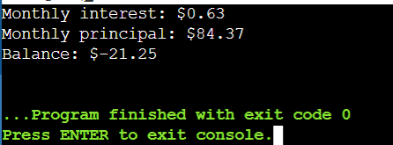

40: Write a solution (algorithm, flowchart and pseudocode) to find the average miles per gallon on a car after six fillups at a gas station. Additional data kept included the number of gallons of gas at each fillup, the starting odometer reading, and the odometer reading at each fillup.

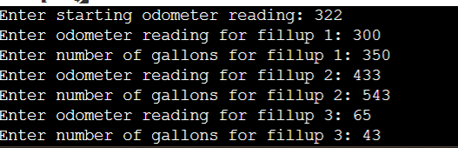

41: Develop a solution (algorithm, flowchart and pseudocode) to calculate a student’s grade average for one semester. The letter grades should be entered and the grade average printed out. An A is equivalent to 4 grade points, a B is 3 grade points; a C is 2 grade points, a D is 1 grade point, and an F is zero grade points.

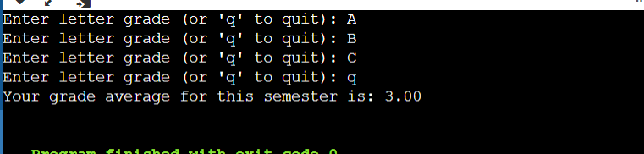

42: Mr. Jones always gives True/False tests to his class. His tests always have 20 questions. The maximum class size is 35. He needs a program that will calculate the students’ rades based on the best score. Grade A will range from the best score, to the best score minus 2. B will range from the best score minus 3, to the best score minus 4. C will range from the best score minus 5, to the best score minus 6. D will range from the best score minus 7, to the best score minus 8. F will be anything below the best score minus 8. Each student’s ID and test answers will be entered. The output will be each student’s ID, number correct, and grade, along with the single highest score for the class. Develop the algorithm, draw the flowchart and write the pseudocode for Mr. Jones’s problem. Use four one-dimensional arrays—one for the correct scores and the other three for the needed output.

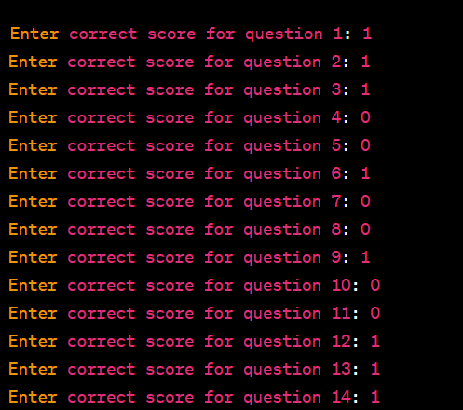

43: A restaurant manager wants to know how many employees are needed at the restaurant each hour of the day. The minimum number of employees needed at any hour is 3. After that, one additional employee is required for each 20 customers. The restaurant is open 24 hours a day. The manager has counted the number of customers each hour for 14 days. The manager will use the average number of customers for each hour over the 14 days to calculate the needed number of employees for each hour. Develop an algorithm, draw the flowchart and write the pseudocode output the needed number of employees per hour. (There is no such thing as a partial employee.)

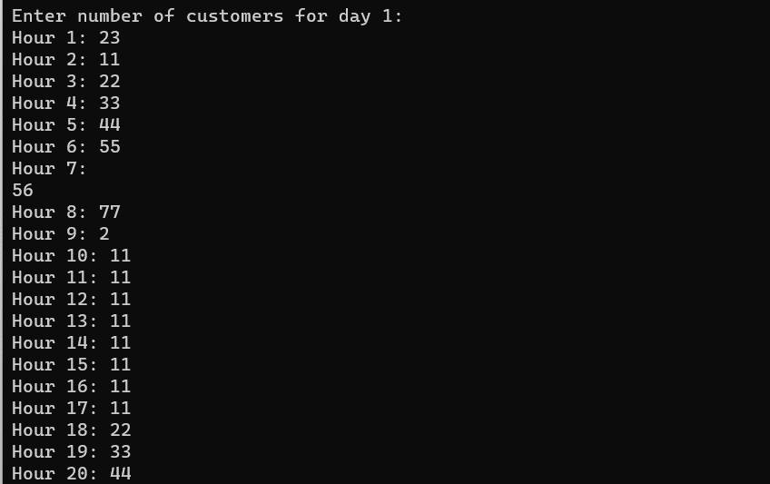44: A company has 10 salespeople. The manager needs to know the average dollar amount of sales for each salesperson for a week, and the total dollar amount of sales for the store for each day and for the week. The store is open 7 days a week, and each salesperson gets 2 days off. The data are entered into a two-dimensional array with the days of the week as the columns and the salespeople as the rows. Develop an algorithm, draw the flowchart and write the pseudocode to output the needed information.

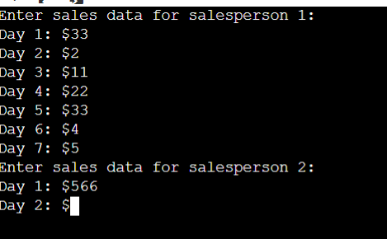

45: An instructor has a class of 25 students. Each student is identified by a number from 1 to 25. All tests are stored in a two-dimensional array, with each column containing the grades for each test. The instructor would like to enter the student number and the test number and have the grade for that test printed on the monitor. Develop an algorithm, draw the flowchart and write the pseudocode to output the needed information.

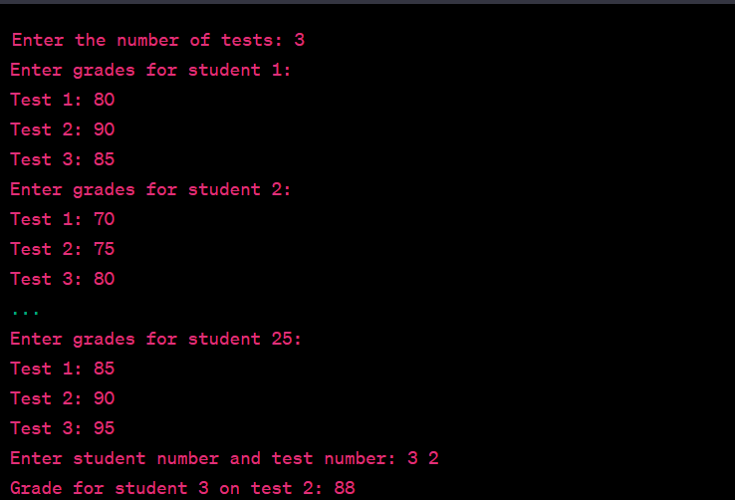

46: The student names and the grades for four tests for Mr. Smith’s class have been placed in parallel arrays. Mr. Smith would like to have one student’s name and test scores printed. Develop an algorithm, draw the flowchart and write the pseudocode that will enter the student’s name, search for the name in the same array, and then print the name and test scores. Use the sequential-search method.

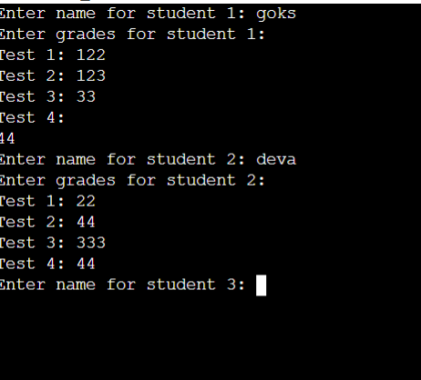

47: The human resources manager of XYZ Corporation would like to analyze the following characteristics of company employees: a. the wages of women compared with those of men b. the total number of employees in each of the 12 departments c. the number of women and men in each of the 12 departments d. the average age of the women and men in each department Develop an algorithm, draw the flowchart and write the pseudocode for this problem

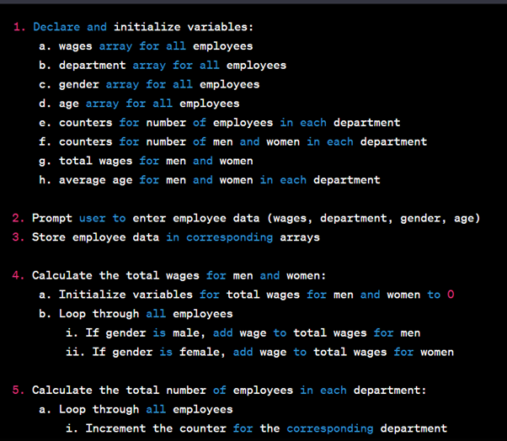

48: A questionnaire was sent to a random selection of the alumni of a college. In all, 95 questionnaires were returned. The questionnaire requested the following items: age gender marital status college major salary The administration would like to know the average salary, given any two sets of items. Develop an algorithm, draw the flowchart and write the pseudocode to cross-tabulate the items and output the needed information. (Remember, the computer cannot divide by zero.)

Here is the pseudocode to cross-tabulate the items and output the average salary given any two sets of items:

1. Initialize variables:
   * age_sum, age_count, gender_count, major_count, salary_sum, num_questionnaires = 0
   * avg_salary = 0
2. Read in the data from the questionnaires:
   * For i = 1 to 95
     + Read in age[i], gender[i], marital_status[i], college_major[i], salary[i]
     + Increment the corresponding count variables:
       - If gender[i] is "M", increment male_count
       - If gender[i] is "F", increment female_count
       - Increment the count for the corresponding college major
3. Prompt the user to enter the two sets of items to cross-tabulate:
   * Prompt for the first set of items (age, gender, marital status, or college major)
   * Prompt for the second set of items (age, gender, marital status, or college major)
4. Calculate the average salary for the selected sets of items:
   * For i = 1 to 95
     + If the questionnaire matches the selected sets of items, add the salary to salary_sum and increment the count
   * If count is greater than 0, calculate the average salary (salary_sum / count)
   * Otherwise, set avg_salary to 0
5. Output the average salary for the selected sets of items:
   * If avg_salary is greater than 0, output the average salary
   * Otherwise, output an error message that no data was found for the selected sets of items
6. End the program

49: A university has four undergraduate class levels and a graduate school. There are 7 majors, although not all students have chosen a major. There are 1,200 students attending the university. The administration would like to know how many students are in each level, and how many students have each major. They also would like to know how many of each class level have declared each major. Develop an algorithm, draw the flowchart and write the pseudocode to output the needed information.

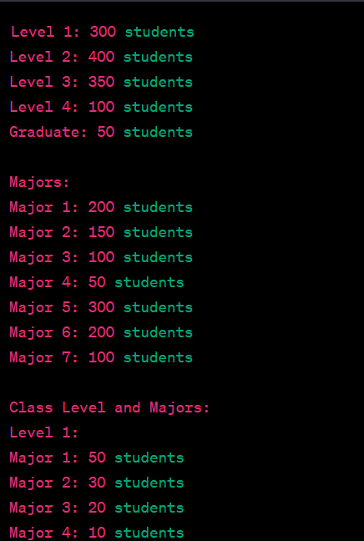

50: John has a weather station in his house. He has been keeping track of the fastest wind speed for each day for two weeks. He would like to know the average wind speed over the two weeks, the days on which the highest wind speed and the lowest wind speed were recorded, and the difference between the highest wind speed recorded and each day’s average wind speed.

